FOOD MANAGEMENT SYSTEM

Use-Case Specification: Display products

Version <1.0>

Revision History

|  |  |  |  |
| --- | --- | --- | --- |
| **Date** | **Version** | **Description** | **Author** |
| <7/12/2020> | <1.0> | <details> | <Nguyen Thu Trang> |

Table of Contents

1. Use-Case Name 4

1.1 Brief Description 4

2. Flow of Events 4

2.1 Basic flow 4

2.2 Alternative flow 4

2.2.1 <First Alternative flow> 4

2.2.1 <Second Alternative flow> 4

3. Special Requirement 4

3.1 <First Special Requirement> 4

4. Preconditions 5

4.1 <Precondition One> 5

5. Posstcondition 5

5.1 <Postcondition One> 5

6. Extension Points 5

6.1 < Name of Extension Points> 5

Use-Case Specification: Display product

1. **Use-Case name**
   1. **Brief Description**

This use case defines the view of menu. The system allow customer view the list of products.

* 1. **Actor**

System

1. **Flow of Events**
   1. **Basic Flow**

First, customer login the system and then click on View of product. The system display product view.

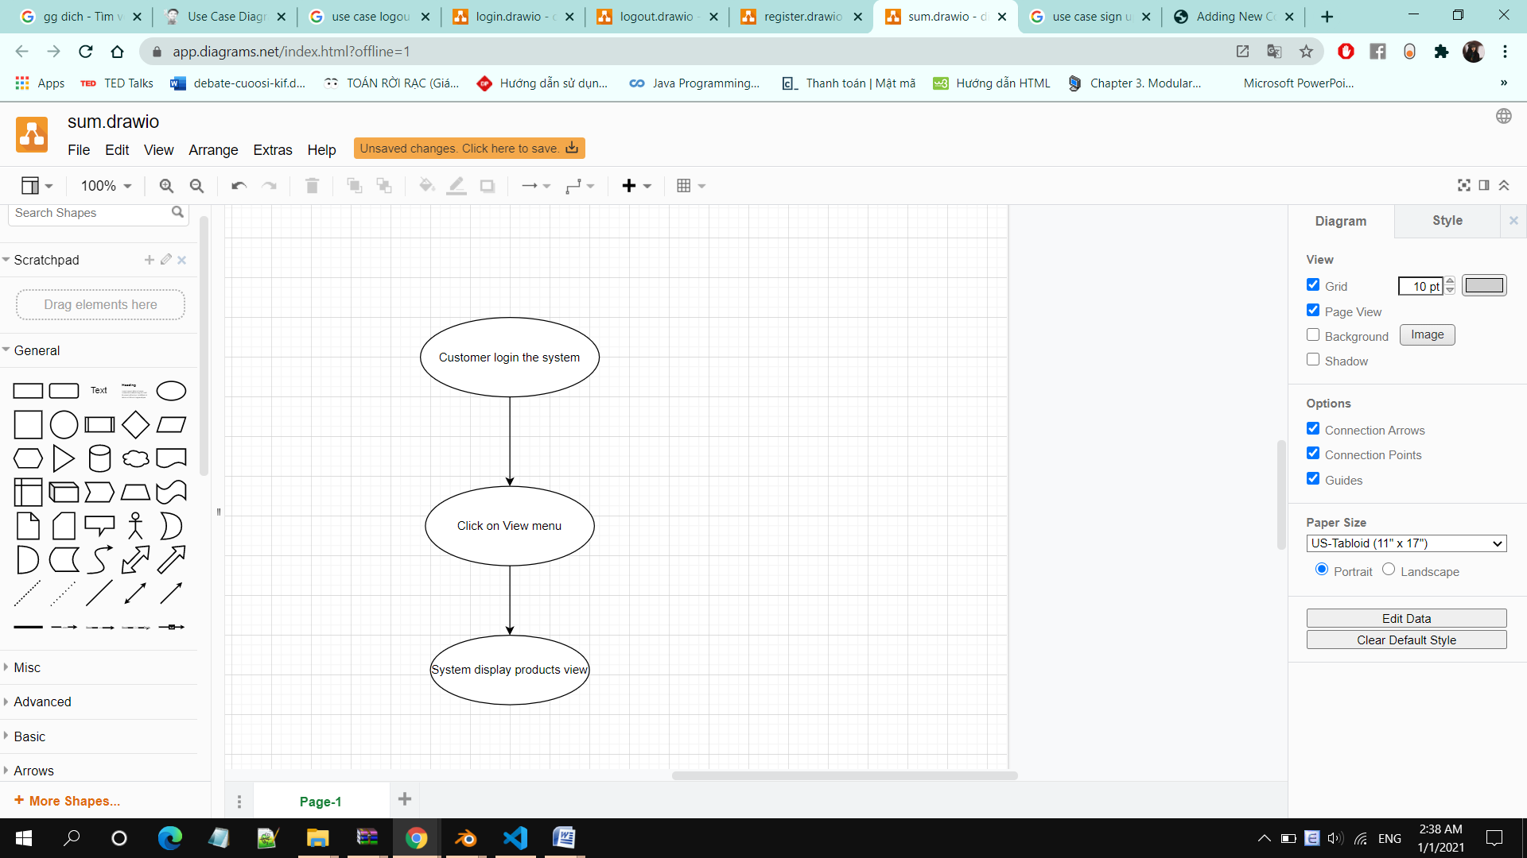

1. **Special Requirements**

Customer must know how to use the product management system.

1. **Preconditions**

Customer already has an accountand log in successful

1. **Postconditions**

Customer views the entire the list of the product

1. **Extension Points**

No extension points.